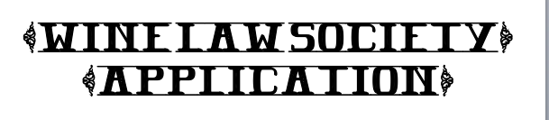

Name:
Email:

The King Hall Wine Law Society (KHWLS) was founded to recognize the interactions between the law and alcohol industry. These include, but are not limited to, agriculture, land use, production, regulation, and (of course) consumption. KHWLS is uniquely situated to work with alumni and geographic connections among Napa Valley wineries, Anderson Valley breweries, Capitol regulators, and many more places in Northern California to encourage specialized programs. By regularly hosting speakers from throughout the industry, students, faculty, and guests engage in educational lectures and discussions.
The current KHWLS Board will vote on the new board. The ideal candidate for each position is creative and passionate about wine, beer, and the alcohol industry. Board members are responsible for spearheading events, being an advocate for the club, and participating in meetings, culture week, and other events. The application in PDF is due to CRDarnell@ucdavis.edu by Saturday, September 30th at 5pm.

- Please rank up to 3 positions that you are interested in.
Note: The board reserves the right to add Class Representatives to the board if there are well-qualified applicants.
Would you be interested in a Class Representative position?
Rank | Position
 | 3L Rep
 | 2L Rep
 | 1L Rep
 | Vice President of Beer
 | Blog Chair
 | Website Chair

- Please describe your qualification for your FIRST choice. (E.g. past experience, professional and amateur interests, etc.)

- Please describe your qualification for your other choices. (Optional)

- What would you most like to learn about and experience in KHWLS?

- What is an idea you have for KHWLS? (E.g. event, speaker, website)

- What would you do on a date with your favorite historical character? (Creativity is favored.)

